logo-defaultUNIVERSIDADE ESTADUAL DE MARINGA

INSTITUTO DE LINGUAS

Atividade de Quarentena 5 – Inter I

Professora Regina Felix

1. Put the verbs in simple past or present perfect:

**not be – happen – have – lose – not pass – spend**

**be - buy – change – have – open – pass**

Last year _________ a good year for Pete and Sonia. Pete ________________ a car accident and ________________ a month in hospital, Sonia ______________ her job, the children ___________________ their school exams, and a lot of other bad things _________________.

This year ______________ much better. Peter _____________ his job, and is making much more money. They __________ a new house. Sonia ___________ a small restaurant and it’s going very well. They __________ a baby. And the other children ________all their exams this time.

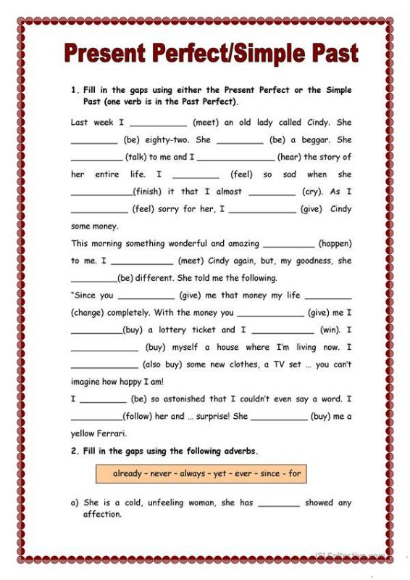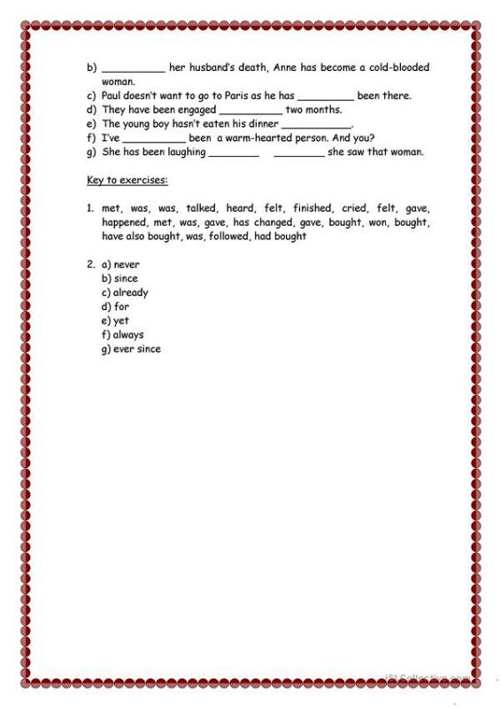

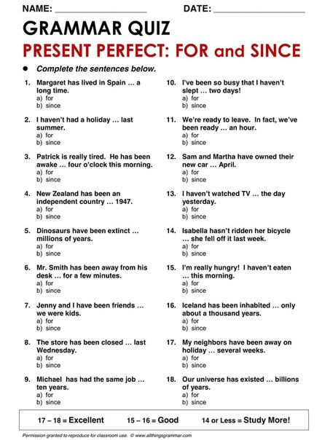

logo-defaultUNIVERSIDADE ESTADUAL DE MARINGA

INSTITUTO DE LINGUAS

Atividade de Quarentena 2 – Inter I

Professora Regina Felix

[felixregina44@gmail.com](mailto:felixregina44@gmail.com)

1- Revising the use of gerund and infinitive, write according to the following.

Things you enjoy doing on Sunday mornings.

I __________________________________________________

Things you enjoy not doing at the weekends.

I __________________________________________________

Things you hate doing.

I___________________________________________________

Things you don´t mind doing.

I____________________________________________________

Attending a college or university usually requires ..............

Attending a ...................._________________________________

2=Now underline in the following paragraph the seventeen verbs which must be followed by infinitive. And then write them below.

The Acme Stamp Company agreed to send Norman some stamps, but when he got them tehy didn´t appear to be in good condition. The company claimed to be reputable, but Norman still felt the stamps were bad. He didn´t care to pay good Money for bad stamps and he felt that he deserved to get a refund. So he decided to phoe the company directly. He demanded to speak to the manager. The manager pretended to be concerned, but he hesitated to make any firm promises about refunds. The company offered to exchange the stamps, but Norman refused to accept the offer. All the stamps from that company semmed to be of poor quality. The company also tended to be very slow in filling orders. Norman has learned to make sure a company is reputable before placing a large order with them. He neglected to do this with the Acme Stamp Company. Norman still hopes to get a refund. He is waiting to se eis the company will give him one before he files a formal complaint with the post office.

1 -____________________________

2 - ____________________________

3 - ____________________________

4- _____________________________

5 - _____________________________

6 - _____________________________

7 - _____________________________

8 - _____________________________

9 - _____________________________

10-_____________________________

11-_____________________________

12-_____________________________

13-_____________________________

14-_____________________________

15-_____________________________

16-_____________________________

17-_____________________________

logo-defaultUNIVERSIDADE ESTADUAL DE MARINGA

INSTITUTO DE LINGUAS

Atividade de Quarentena 3 – Inter I

Professora Regina Felix

[felixregina44@gmail.com](mailto:felixregina44@gmail.com)

1. Fill in the blanks with the correct form of the verbs in parentheses. There may be more than one correct answer.

Before the invention of radio and television, people spent much of their leisure time _______ (do) activities that required _______ (do) or _______ (make) something. They practiced _______ (play) a musical instrument or studied _______ (sing).

Most people learned _____ (keep busy) by _____ (try) ______ (improve) their abilities in some way or by ______ (practice) a skill. People who couldn´t afford ______ (spend) much Money on hobbies often started ______ (collect) simple objects, such as matchbook covers or stamps, or even things like buttons or bottle caps. Of course, most people spent a loto f time ______ (read), and ______ (write) letters to friends.

Children played games in which they pretended _____ (be) pirates or cowboys or people they remembered _______ (read about) in books. Many women were extremely clever at ______ (make) and ______ (decorate) articles of clothing. Men often kept busy by _____ (make) toys for children or _____ (carve) small sculptures out of wood.

logo-defaultUNIVERSIDADE ESTADUAL DE MARINGA

INSTITUTO DE LINGUAS

Atividade de Quarentena 4 – Inter I

Professora Regina Felix

[felixregina44@gmail.com](mailto:felixregina44@gmail.com)

1. Complete the sentences using **too** or **very.**
2. We got there _____ late. The plane had already taken off.
3. I´m ______ busy, but I think I can finish the report for you.
4. Denise Works _____ hard for her own good. She´s going to get sick if she´s not careful.
5. Denise works _____ hard because she´s ambitious and wants to get ahead.
6. Don´t bother to invite Jose to the party. He´s _____ serious to have any fun!
7. The accident happened _____ quickly, but I´m _____ sure that the driver of the sports car didin´t use his turn signal.
8. Children are growing up _____ quickly these days. They try to act like adults while they´re still kids!
9. We arrived at the party ______ late. All the guests had left.
10. I really like Mary. I think she´s ______ intelligent and has a great personality.
11. It´s _____ hot. Let´s forget about the tennis game.